7 Ways TapRooT® Can Help Improve your Safety Performance
Dave Janney
System Improvements, Inc.
Knoxville, Tennessee, USA


Companies spend enormous amounts of time, energy, and money to solve problems and reduce failure costs. Some others relax, hope for the best, wait for major problems to occur, and then slip into crisis mode. Each business and industry is unique and has its own set of challenges; however, one thing all business has in common is that in today’s world you must be efficient, cost conscious, and provide the most value to your customers versus the competition.

The modern safety professional cannot afford to be a firefighter or a cop. Safety has to be integrated into the business and must produce results. The profession is evolving, and what I like the most about safety people is that they thirst for the latest technology and have a real desire to be the best they can. At System Improvements, we want to help you do that.

The list of things you can use TapRooT® for and the reasons to use TapRooT® are almost endless. Nonetheless, at times it is best to break things down into bite-sized pieces. Thus, I would like to suggest 7 ways TapRooT® can help improve your safety performance.

- A standardized investigation method

Some companies, particularly large ones, use an array of tools and methods. The safety people might use one method, and the quality people might use another. One division uses one method, and one uses another. One method is used for serious incidents, and another (or several others!) for minor issues. This results in a disconnect between groups, and an impossible task when trying to trend and truly understand the company’s problems and the risk that is present to the organization. Standardizing to one method allows for everyone to speak the same language, trend root cause data, streamline reporting, and partner on training and software.

One of the common issues mentioned above is using different methods for serious and minor incidents, for example, a “5-Why” analysis being used for minor issues. Normally some type of risk matrix is used to determine the required method. While this makes sense at first glance, the problem with this approach is many times the data for the lower level incidents is faulty and the corrective actions are not effective. In other words, the time spent on this endeavor is essentially wasted time. If you are not going to (or are not able to) investigate smaller incidents well, it is better to categorize them well and comprehensively investigate the trends that surface.

TapRooT® is not just for serious or major incidents; it is fully scalable. A simple investigation is likely to have fewer causal factors, fewer root causes, and less involved corrective actions, so it is easy to do a simple investigation using TapRooT® in a short period of time. For information on using TapRooT® for low/medium risk incidents and simple investigations, refer to the book “Using the Essential TapRooT® Techniques to Investigate Low-to-Medium Risk Incidents,” which is book #3 of the series of TapRooT® books.


While it may not be feasible to investigate everything, you should investigate as many smaller incidents as possible. While not all small incidents involve hazards that can cause serious injuries or fatalities (SIFs), some certainly do. Smaller incidents that could have had larger consequences (precursor incidents or high potential incidents/HIPO) as well as high potential near-misses should be investigated to their fullest potential.

For higher-risk and more complex problems, refer to the book “Using TapRooT® Root Cause Analysis for Major Investigations,” book #4 of the TapRooT® book series. The TapRooT® 7-Step process gives investigators a road map and structured process full of robust tools to make sure all parts of the investigation are solid.

- Achieve better corrective actions to avoid repeat incidents

Good investigations are an important facet of any safety improvement journey; however, without good corrective actions, an investigation is nothing more than a paperwork exercise. Corrective actions are the OUTPUT of an investigation and are the most important part.

Why don’t people always write effective corrective actions? There are a lot of reasons, but here are a few:
- Corrective actions are at the END of an investigation. What happens at the end of anything? People are tired and want to be finished. To quote a well-known safety practitioner, Larry the Cable Guy, let’s “Get ‘er done!” Unfortunately, this is human nature, and I can’t help with that. Corrective actions will always be at the end.
- They write the same corrective actions over and over. If it did not work last time, why will it work this time?
- They don’t know how to write effective corrective actions. TapRooT® has a number of tools and concepts that can help with this.
- The root causes do not correlate to the corrective actions. For example, a training corrective action for a non-training problem. In order to write effective corrective actions, you have to first have accurate root causes. In TapRooT®, we understand WHAT happened first, WHY (root cause) next, and then FIX (corrective actions).

Here are some examples of weak corrective actions you may have seen in your reports (courtesy of Ken Turnbull, one of our longtime instructors):

Can’t Close
- Assure
- Ensure
- Insure

Pass the Buck
- Review
- Recommend
- Study

Hidden Discipline
- Remind
- Review with
- Counsel
- Present

My preferred method (tongue firmly planted in cheek) is the Combination:

Ensure employees follow all procedures and recommend the safety department study compliance and review findings with all employees.

Sounds great, doesn’t it? The only problem is we have not fixed anything!

How many repeat incidents do you have at your company?

The TapRooT® tools and techniques we teach help you write more accurate and applicable corrective actions:

The TapRooT® Corrective Action Helper® has suggestions for improvement and guidance for every root cause on the TapRooT® Root Cause Tree®. It includes a check to focus you on the root cause being corrected, suggestions for fixes, a prompt to look for Generic (Systemic) Causes, and references. Using the Corrective Action Helper® makes you much more disciplined when developing corrective actions.

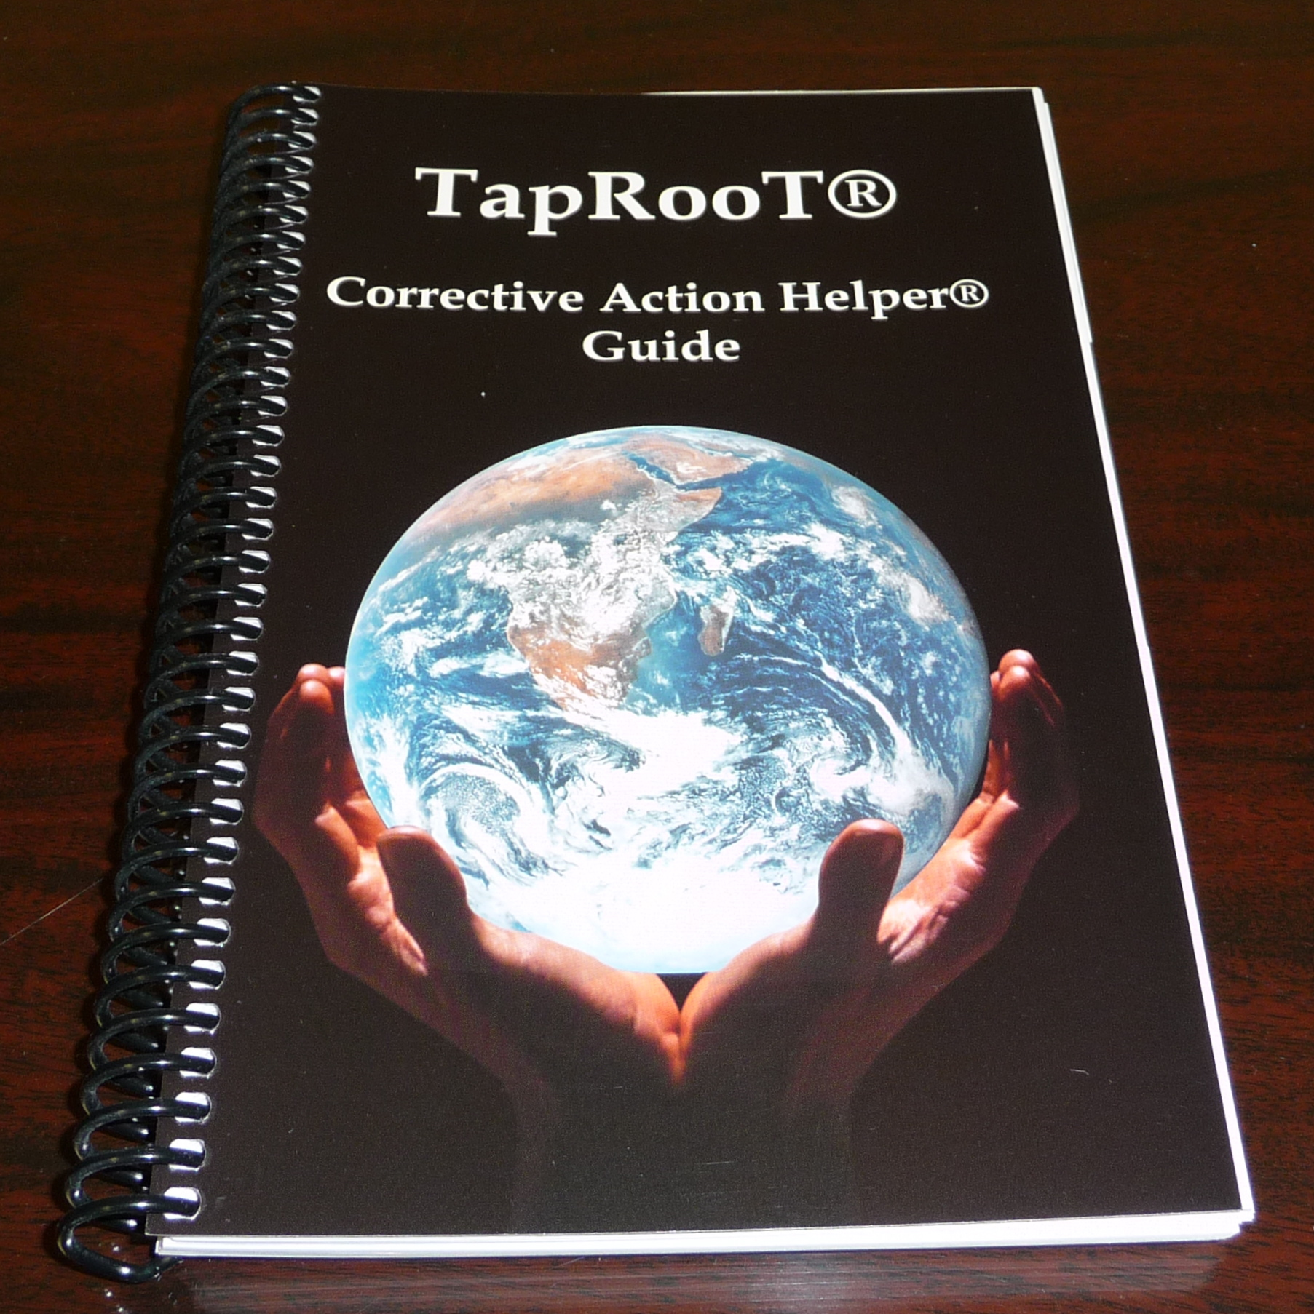

We also teach the concept of Safeguard Analysis (also known as Barrier Analysis) and Defense in Depth (also known as layers of protection or LOPA). The following diagram shows Safeguards in order of effectiveness:

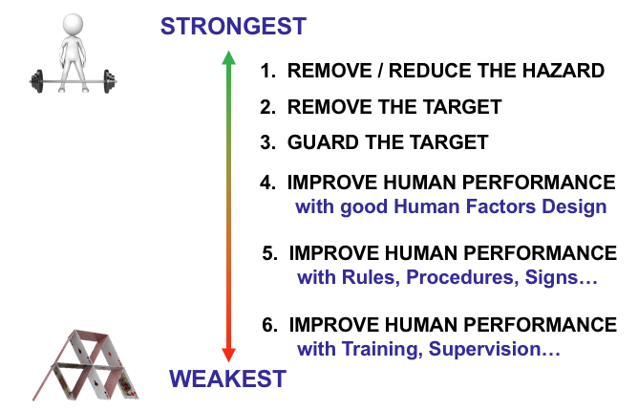

An eye-opening experiment is to pull out a stack of old reports from your company and rank the corrective actions based on this diagram. If you find that most of your corrective actions are 5s and 6s, I have just given you the answer as to why you have so many repeat incidents.

Don’t misunderstand me. I am not saying that you do not need procedures or training, but those are in place to make humans more reliable. As we all know, humans are reliably unreliable! We all make mistakes, so why not remove that possibility if we can?

- A structured approach to collecting evidence

As mentioned earlier, in order to have good corrective actions, you have to have good root cause analysis. It begins with GOOD INFORMATION (evidence). In TapRooT®, we seek to understand WHAT happened first, WHY (root cause) next, and then FIX (corrective actions).

We teach a number of evidence collection techniques in our courses:
- The TapRooT® 12-Step Cognitive Interview Process
- 3 P’s and an R (People, Physical, Paper, and Recordings)
- CHAP (Critical Human Action Profile)
- Change Analysis
- Equifactor® (for Equipment troubleshooting)

All of these tools help us gather information for the backbone of every TapRooT® investigation, the SnapCharT®:

Far too many investigations go blindly into root cause analysis without solid evidence. Even worse, sometimes root cause analysis is left out entirely. Evidence collection is (or should be) the majority of the work involved in an investigation. Without it being done comprehensively and accurately, the rest of the process is bound to fail. The SnapCharT® keeps you focused on what you have already, what else you need to collect, and what needs to be verified. It tells the story of what happened and provides a visual timeline and a repository for all the evidence collected. It will later provide solid evidence for the root cause analysis—and not just any root cause analysis, rather, a fact-based root cause analysis. As a master investigator (Dragnet’s Joe Friday) once said, “Just the facts, just the facts!”

Evidence collection (and interviewing in particular) is a skill that has to be learned. We provide the training and tools to help investigators develop that skill. For more information, refer to the book “Evidence Collection and Interviewing Techniques to Sharpen Investigation Skills,” which is book #7 of the TapRooT® book series.

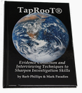

- Expert guidance to find root causes

A common problem with root cause analysis is the lack of knowledge of the analyst, as everyone is an expert at something, but most of us are not experts at everything. Another common problem is that analysts are often so experienced in their business, their bias drives the analysis (this is called “confirmation bias”). Both problems lead to a similar outcome: wrong answers at worst or the obvious or superficial at best. What is far more effective is a guided, expert system that identifies all deficiencies. A tool that uses proven human performance and reliability research rather than relying on the experience (of lack thereof) of the analyst, the TapRooT® Root Cause Tree® (and Root Cause Tree® Dictionary):

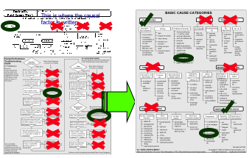

The Root Cause Tree® and Dictionary allow the analyst to use the research in a set of well-defined questions that, along with the evidence collected, yields true root causes. TapRooT® is not a single root cause system, rather a system that finds ALL root causes. This provides not only better results but also consistency. It is quite telling when a class of 30 people does a root cause analysis and everyone gets the same results. This consistency is what allows for proper trending over time that helps reveal systemic problems, which in TapRooT® we refer to as Generic Cause.

Generic Cause analysis is an optional part of the TapRooT® system which encourages the identification of the systemic problem that allows a root cause to exist. Fixing problems at this level yields wide-scale improvements.

- Proactive improvement to prevent incidents from occurring

The most important (in the author’s opinion, that is) part of a safety program is proactive improvement. Unfortunately, this is an area where many organizations fall short. However, when done well, proactive activities can yield results far beyond the results of good investigations.

Proactive improvement can take many forms and, when effective, becomes an overall mindset and can put an organization on the path to excellence. If that is the case, why are more companies not proactive? Here are just a few reasons:
- Time (perceived at least)
- They don’t have a reason to (not enough pain)
- They do not have the buy-in (management and employee support)
- Procrastination (human nature!)
- They don’t know how (this is where TapRooT® comes in!)

TapRooT®, when used with auditing and proactive improvement programs, can help lead to organizational excellence and greatly reduce the number of investigations required.

Most companies do audits. However, many times improvements are not realized. Why? Many reasons exist, but one major reason is that corrective actions are developed from the findings rather than the root causes of the findings. In order to actually solve the issue, you have to first know the actual root causes.

Many other forms of proactive improvement, such as Six Sigma, Lean, or Plan/Do/Check/Act (PDCA) help organizations improve (when they are properly implemented, that is). However, while they can be effective processes, they typically involve weak root cause tools. By incorporating TapRooT® into existing programs as the root cause tool, organizations can realize better results from these efforts.

For more information, please refer to the book “TapRooT® Root Cause Analysis for Audits and Proactive Improvement,” which is book #6 in the TapRooT® book series.



- Productivity

Using TapRooT® will make your investigators and auditors more productive by using a proven and structured system. Using the TapRooT® software will make them even more productive. The software utilizes the TapRooT® workflow for simple or major investigations and associated tools to walk the investigator or auditor through the process, while capturing and preserving the data. The ability to use a closed-loop enhanced with automation allows for a faster process with reporting functions and trackable results. On a system level, the ability to trend root cause data and spot generic/system issues allows for better problem identification and decision-making. In addition to reporting, the TapRooT® VI Software’s “Report Builder” tool can also produce management presentations. A standardized report and presentation saves time and makes for shorter and more effective meetings.

- Employee development from enhanced knowledge

This is the hardest to quantify; however, when employees have a better understanding of root cause, corrective action, human performance, and accident theory, they become more effective in their everyday work.

For example, one of the concepts we teach is Safeguard Analysis (also sometimes known as Barrier Analysis). In TapRooT®, we use Safeguard Analysis to help us find causal factors, and we also use it later in the process to develop better corrective actions. Beyond investigations, it can also be used proactively for audit planning. When employees begin to think in terms of Safeguards, they start to notice problems during the normal course of their work that they would not have otherwise. Additionally, when developing new processes, writing procedures, developing training, purchasing equipment, and many other activities, they consider Safeguards during development. They also are better able to develop Defense-in-depth (layers of protection) and spot deficiencies.

A major benefit of becoming a TapRooT® user is enhanced knowledge of human performance in general. For example, when investigating a procedure problem, the TapRooT® Root Cause Tree®, Root Cause Tree® Dictionary, and Corrective Action Helper® teach what a good procedure looks like. In the Human Engineering section, they become knowledgeable about human/machine interface and work environment issues. The Root Cause Tree® should be considered a collection of best practices, that is, a collection of things you should have in place to make your employees more reliable. Imagine having a group of employees that are familiar with and understand human performance concepts.

The best practices on the Root Cause Tree® are included in an Equipment Category as well 7 Human Performance Categories:
- Procedures
- Training
- Quality Control
- Communications
- Management System
- Human Engineering
- Work Direction

In addition to this enhanced knowledge that can be used every day, they become much better investigators and auditors.

Thank you for reading!

We hope this paper gives food for thought. Organizations that want to get better and leverage the best technology have an option for improvement: the TapRooT® System.

TapRooT® is used worldwide in almost every industry imaginable. Why can one system satisfy the needs of different operations, cultures, and disciplines? Because people are involved, and people make mistakes for the same reasons, regardless of where they work. Systemic reasons. Human performance limitations. At System Improvements, Inc., our goal for 30 years has been to Change the Way the World Solves Problems. We do this with the best complete investigative and root cause system, TapRooT®.

For more information and to better understand how we can help, please contact us:

info@taproot.com

www.taproot.com

001-865-539-2139

